

Web development (Lab)
Lab task 2

Submitted to: Sir Usman Akram
Submitted by: Momina Kashif
Roll no: FA24-BCS-057
Class: BCS-B

Desktop width:
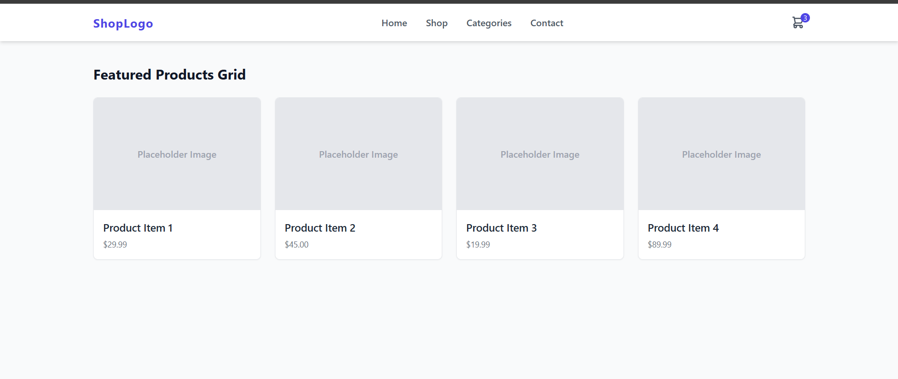

Tablet width:

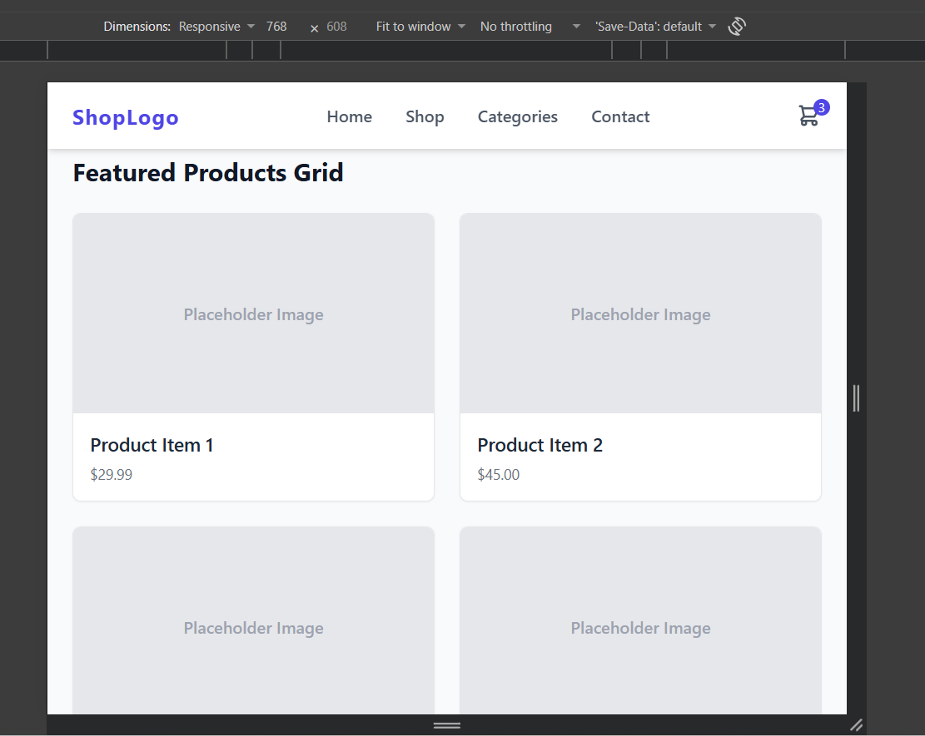
Mobile Width:
